THE CHILDREN’S MEMORIAL HEALTH INSTITUTE

REVISED HUMAN RESOURCES STRATEGY FOR RESEARCHERS

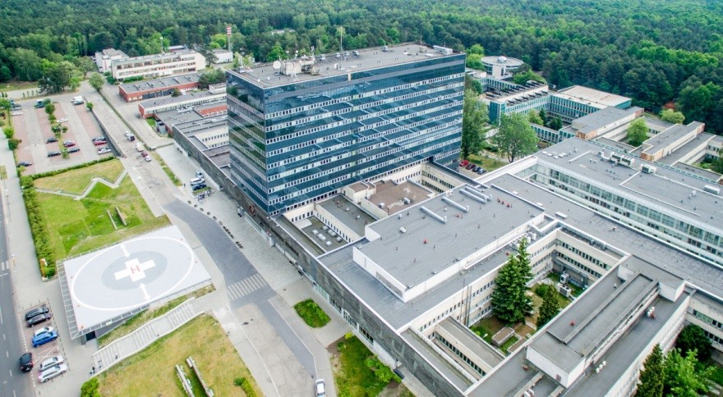

Warsaw, June 2019 r.

Contents
Introduction 3
The Recovery Plan implementation 3
The Recruitment procedure for research positions (OTM-R policy) 4
Revised HR strategy 4

Introduction
The Children's Memorial Health Institute (hereinafter referred to as the Institute or CMHI) is a research institute, as well as one of the largest specialised paediatric hospitals in Poland working for modern paediatrics. The subject of the Institute's activity is conducting scientific research and development works, therapeutic and service activities aimed at health needs of children, youth and young adults, and also implementation of didactic tasks, adapting the results of scientific research and development works to the needs of practice and implementing their results. The founding body of the Institute is the Council of Ministers. Scientific and clinical achievements are the result of nearly 40 years of work of the medical team.

The Children's Memorial Health Institute obtained the highest A + category in the parametric comprehensive assessment of the scientific or research and development quality of scientific entities carried out by the Committee for the Evaluation of Scientific Units complying with the regulations of the Ministry of Science and Higher Education. The final grade placed the Institute in the first position out of 22 assessed units in the joint assessment group (pol. GWO) where only 2 units obtained the category A +. CMHI is thus one of two units with the status of a research institute out of 39 assessed ones in the group of Life Sciences, which obtained the highest category.

In 2010 - 2018, the Institute implemented 74 projects financed from national sources (the Ministry of Science and Higher Education, the National Science Center, National Center for Research and Development), 38 projects financed/co-financed from foreign sources (including projects under: EU Framework Programmes, Community Action Programmes for Health, the EEA (European Economic Area) Financial Mechanism and the Norwegian Financial Mechanism, structural funds, the Swiss-Polish Cooperation Programme, the Leonardo da Vinci Programme, the EUROSTARS Programme, the ERA-NET eRare Programme and a project funded by WHO), 5 projects financed by Nutricia Foundation and participated in the implementation of 6 surveys conducted by foreign centres. CMHI is the coordinator of 2 international projects co-financed by the EC under the Seventh Framework Programme and the Horizon 2020 Programme. Additionally, at the same time, the Institute carried out 194 internal research projects - internal grants, statutory research tasks and research tasks for the development of young scientists financed from the funds of the Ministry of Science and Higher Education.

The CMHI currently employs 99 scientists, including 17 people - as full professor.

The Recovery Plan implementation
Thanks to receiving the HR Logo distinction in June 2017, the Institute was placed among the entities implementing the European Charter for Researchers and the Code of Conduct for the Recruitment of Researchers. The Charter and the Code provide equal rights and obligations for researchers across Europe, defining the roles, responsibilities and rights of researchers and employers.

Since the award of the HR Logo distinction, intensive work has been launched to implement the recovery plan. The managers of all involved units of the Institute were notified of their duties. On December 13, 2017, pursuant to Regulation No. 71/2017, the Director of the CMHI established the Team for the implementation of the European Charter for Researchers and the Code of Conduct for the Recruitment of Researchers. The team organised meetings on average once every 6 months or more often. During the team meetings, the status of task implementation was monitored and the direction of further corrective actions was determined.

The Scientific Research and International Cooperation Division coordinated the progress of implementing the provisions of the European Charter for Researchers and the Code of Conduct for the recruitment of researchers, supporting individual units. The reports presenting the scope of performed activities have been prepared on an ongoing basis over the past two years. In addition, for the purposes of ISO accreditation, which took place in June 2018, the Research Department has prepared a progress report, constituting the basis for studying the satisfaction of researchers/the Institute.

The progress of works has been monitored on a regular basis, however, the implementation of several tasks has been extended, and some of them have been completed after the time specified in the recovery plan. The main delays in the implementation of tasks resulted from the amendment of the law on higher education and science in October 2018. - Law 2.0 - Constitution for Science. The introduction of this law imposed on the Ministry of Science and Higher Education the necessity to develop guidelines and executive acts to the Law. Only after releasing the indicated documents will action related to, among others, verification of work in the central anti-plagiarism system and the implementation of regulation No. 536 of the Council and the European Commission (task T2) or activities concerning the publication of information on the nauka.czd.pl website on the possibilities of scientific career development at CMHI (task T12) be undertaken.

There was an open approach to the majority of the tasks carried out, taking into account the resources available and other methods of implementing a given activity. Therefore, within the framework of task T7 aiming at conducting the training in the dissemination of research results, the focus was on the dissemination methods already in operation at the Institute. What is more, a great emphasis is put on the newly created website nauka.czd.pl, which is going to be the main pillar in the promotion of science in our Institute. The conducted survey examining the state of academic supervision at the CMHI has shown that to complete the tasks devoted to it (T20 and T22), it is necessary to establish the Mentoring Programme. In addition, the introduction of the recruitment procedure for research positions took longer than expected due to the need to develop a document that would be in line with the provisions of both the CMHI Statute and the Law on Research Institutions and the Law on Higher Education and Science. According to the assumptions of the European Charter for Researchers and the Code of Conduct for the Recruitment of Researchers, the implementation of the new HR strategy is a continuous process, and consequently all actions implemented under the Recovery Plan will be consistently implemented and realised.

The Recruitment procedure for research positions (OTM-R policy)
Properly developed recruitment of employees constitutes the core element of the entire HR strategy. It is the selection of the right candidate that conditions a whole range of other HR processes. Following the Charter and Code guidelines the Institute began to develop an open, transparent and clear recruitment policy. The indicated document aimed at adjusting the current Competition Procedure for research positions to the OTM-R assumptions and describing the recruitment process in the simplest, yet legible way. During the preparation of the procedure, particular attention was paid to complying - both with the CMHI Statute and with the Act on Research Institutes. Any delays in the implementation of the procedure resulted from the need to harmonise its provisions with the CMHI Statute. The provisions of the procedure were enriched by a paragraph on the OTM-R assumptions concerning the principle of non-discrimination and transparency of each stage of recruitment. The developed procedure is part of the ISO process and provides clear guidelines for all people involved. The upcoming competitions for research positions will be carried out in accordance with the new procedure. New tasks involve the delivery of training for employees engaged in the aforesaid process and the creation of appropriate tools to test the effectiveness of the recruitment.

Revised HR strategy
In accordance with the necessity to prepare the internal review, the previous activities were summarised and a new, updated HR strategy was developed. As mentioned in the part devoted to the implementation of the recovery plan, the Scientific Research and International Cooperation Division monitored the progress of tasks on a regular basis and prepared regular reports, thanks to which an overview of the current state of implementation of activities was available. The new tasks described in the report constitute both a continuation and consistency of the tasks adopted at the application stage for the HR Logo distinction. As part of the updated HR strategy, the assumptions resulting from the implementation of the initially accepted tasks (tasks T1-T22) will be continued, and new tasks will be undertaken (tasks T23-T32).
A cycle of trainings is planned to ensure equal access to training and continuous professional development for researchers. In order to practically explore ethical principles and respect freedom of scientific research, trainings on complying with the introduced Researcher’s Code of Ethics (T23) will be carried out. Moreover, training in intellectual property rights and copyrights, supplemented with examples from the life of CMHI (T24), will also be continued. According to the previous practice, all trainings will be supplemented with a discussion panel, during which employees will be able to submit their comments on the content of existing documents, as well as problems faced by them in their scientific work. In order to ensure constant professional development of our scientists, there will be trainings on the so-called ‘Scientist's workshop’ (T30), including, among others, library and statistical training, dissemination of research results, methodology of scientific research and development of results. The key element ensuring full access to training for each CMHI employee will be the creation of an e-learning platform (T25), on which materials from all trainings, clinical meetings and Tuesday meetings etc. will be placed. New tasks will also include the database on Electronic Science Platform, which will contain information on project results (T32).
As far as the personnel selection process is concerned, there are plans to revise and update the criteria for requirements contained in notices for competitions in accordance with the guidelines of the Scientific Council and, if necessary, specify minimum values ​​for research positions requirements (T26). In connection with the introduced Recruitment Procedure for research positions, training on the application of the OTM-R principles is planned for all employees involved in the recruitment process (T27). In addition, a tool will be developed to examine the Recruitment Procedure for research positions, for example in the form of a questionnaire for candidates (T28). As regards the assessment of merits, a re-updating of the academic staff assessment is also planned, which will match the requirements of Law 2.0 - Constitution for Science (T29) introduced in 2018.
In the near future, the implementation team will also focus on intensifying activities promoting the received HR Logo distinction and all actions taken as part of the recovery plan (T31). The Scientific Research and International Cooperation Division together with the Office for Communication and Marketing will be preparing short news to be posted on the website czd.pl, a new website dedicated to science: nauka.czd.pl and in social media. The information will be available to both the Institute's employees and outside persons.

The new activities listed above have been described in detail in the Internal review (Actions). As mentioned earlier, the implementation of the provisions of the European Charter for Researchers and the Code of Conduct for the Recruitment of Researchers is a continuous process, and consequently all actions implemented under the Recovery Plan and described in this document will be consistently implemented and realised.

